Section 4(i) |  | Corporate Profile
Section 4(i)(b) |  | Detailed information of not more than 5 job references for each discipline of similar size as the Accommodation
6.0 | Property Management Services Provider    - Company Profile  China Overseas Holding Limited was established in Hong Kong in June 1979. It is a subsidiary of China State Construction Engineering Corporation Limited, with five listed companies in Hong Kong covering business areas such as real estate development and operation, construction and infrastructure investment, property services, etc. China Overseas Group has become the highest-rated real estate development and operation company in the mainland Chinese market, with the highest brand value and the largest single ownership office building scale. It is also the largest engineering contractor, the largest Chinese-funded real estate developer, and the largest public facilities property service provider in the Hong Kong and Macau regions. Currently, its total assets exceed 1.2 trillion yuan.  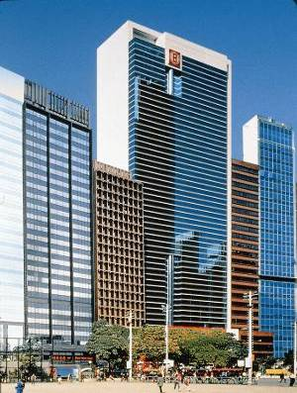  World-class Investment, Construction and Operation Service Provider  China Overseas Property Service Limited (COPSL), which was established in Hong Kong on December 23, 1986, is a wholly-owned subsidiary of China Overseas Holding Limited (Code: 2669) and with eight subsidiary companies in the region. We have a heritage of professional property management services provision since 1986 for our customers over Hong Kong and Macau. Our business covers ten major categories, including Central Government and Military Bases projects in Hong Kong and Macau, Hong Kong Government public buildings, commercial office buildings, high-end residential properties, high schools, hospitals, cultural heritage sites, etc.  Our services include but not limited to the following aspects:  - Security - Customer Services - Landscape - Cleaning & Pest Control - Repair & maintenance - Takeover of Properties - Emergency Handling - Project Consultancy - Tenancy & Leasing Management - Crowd Control Management - Event and Promotion Management - Financial Management  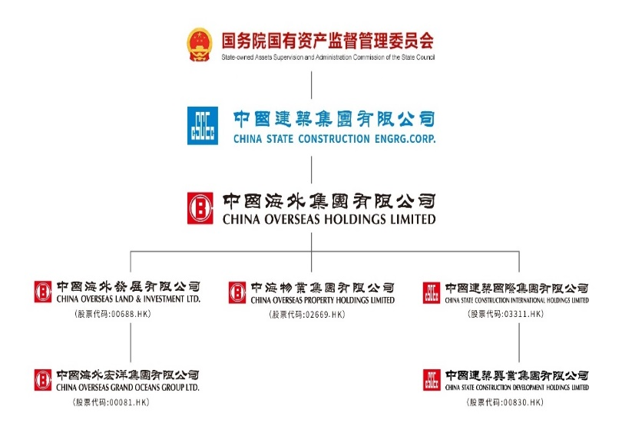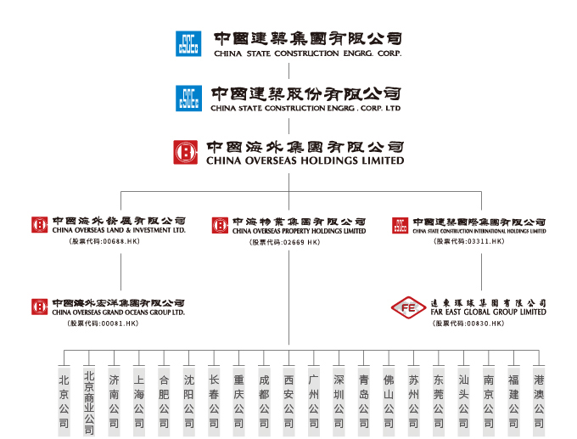  COPSL currently employs over 10,000 staff and manages 260 projects, covering an area of over 12 million square meters. Our services extend beyond private projects to include numerous Government initiatives, currently serving three bureaux, twelve departments, and twenty-two executive bodies. Our advantageous position continues to grow significantly.  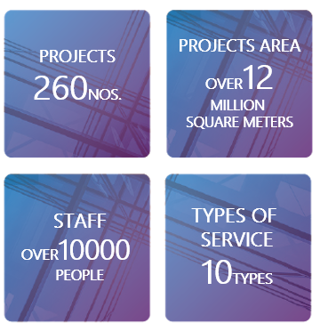  COPSL has been providing Property Management Services to those Venues at a remarkable standard. The properties included, but not limited to the followings:  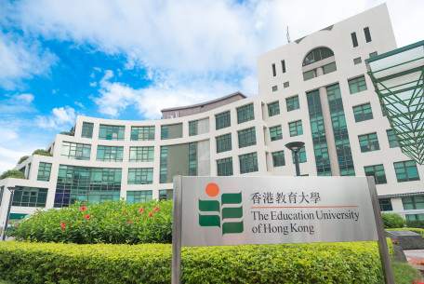  Educational Facilities  - The Education University of Hong Kong  - The Create of the Hang Seng University of Hong Kong  - Hong Kong Art Centre and Art School Campuses  - Government Accommodation at Landmark South of Hong Kong Arts Development Council  - Korean International School Hong Kong  The Education University  of Hong Kong  - Bethel High School  - University of Macau (Our Groups Company’s project)  - Macau University of Science and Technology  - Tsinghua Shenzhen International Graduate School  - Remin University of China Tongzhou Campus  Government Complexes and Headquarters Buildings  - Hong Kong Police Headquarters Complex  - Customs Headquarters Building  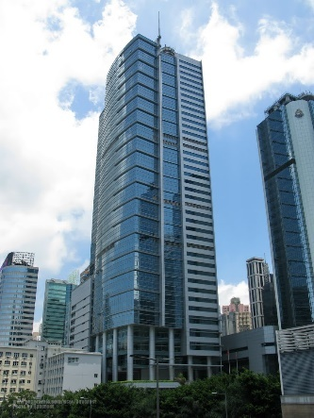  - The Justice Place and the former French Mission Building  The Hong Kong Police Headquarters Complex  - Housing Authority Head Office  - APB Centre (Office of Architecture Services Department)  - Tuen Mun Siu Lun Government Complex  - Tseng Choi Street Government Services Complex  - Kowloon East Regional Headquarters and Operational Base cum Ngau Tau Kok Divisional Police Station  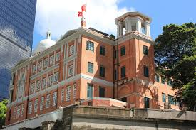  Cultural and Recreational Facilities  The Justice Place and  the former French Mission Building  - Hong Kong Palace Museum  - Hong Kong Museum of Art  - H6 CONET and 7 Mallory Street  - The City Gallery  - Oil Street Art Space  - Hog Kong Visual Arts Centre  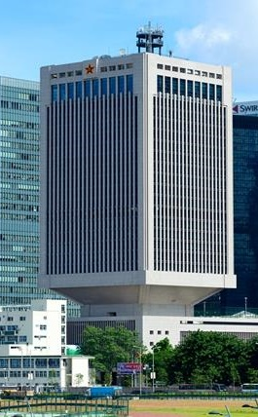  - Kai Tak Cruise Terminal  Chinese People's Lib-eration Army Forces Hong Kong Building  - Sham Shui Po Library  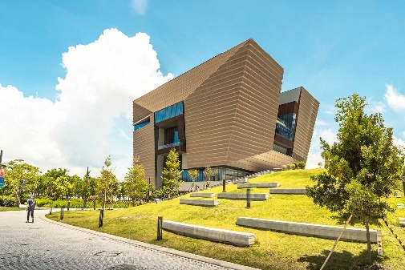    Hong Kong Palace Museum  Kai Tak Cruise Terminal  Leveraging this abundant and directly relevant experience, COPSL possesses the proven expertise, scalable resources, and dedicated commitment necessary to deliver outstanding property management services to the Student Hostel of The University of Hong Kong. We are confident that our demonstrable track record of excellence makes us the strategic and reliable partner of choice for this important contract.  
Project: | One Kai Tak


Project Description
One Kai Tak is a unique private residential estate located at 2 Muk Ning Street, Kai Tak, Kowloon. The development comprises two phases, totaling 17 blocks with 1,169 residential units, and was completed in 2017. The two clubhouses feature amenities including a swimming pool, dynamic fitness center, children's playground, flight simulator, karaoke room, and banquet hall. A two-storey shopping mall within the estate offers a supermarket, restaurants, and various retail stores to meet daily needs.
Annual Conntract Sum: | HK$112.2M
Contract Period: | 2017/10/27-present
Number of Rooms: | 1,169
Client: | Owners Corporation
Details of awards and other performance-based prizes, accolades and letters of appreciation

2022 | 精英大獎2022 - 傑出團隊大獎 & 卓越獎
11.2023 | 香港地產行政師學會大獎 -綠色設施物業管理大獎
5.2024 | 可持續發展物業2024 -可持續發展物業貢獻金奨-推動綠色環保獎項
9.2024 | 卓越設施管理獎2023/2024 - 卓越設施管理獎(中型住宅)-超卓獎"
9.2024 | 卓越設施管理獎2023/2024 - 最受歡迎設施獎(住宅項目) -金獎"
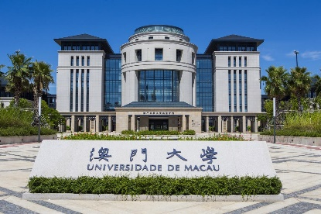
University of Macau
Project: | One Victoria
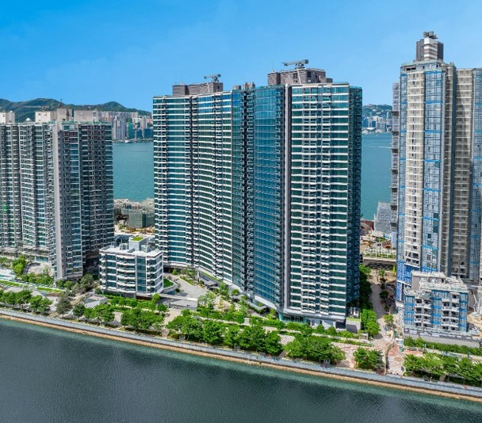

Project Description
One Victoria is a prominent private residential estate located at 21 Shing Fung Road in the Kai Tak area of Kowloon, Hong Kong. Completed in July 2022, the estate comprises five tower blocks, offering a total of 1,059 residential units. The management team is responsible for maintaining the estate's impressive Club Victoria, a dual-clubhouse facility that spans over 90,000 square feet, including landscaped gardens. It features more than 30 amenities across six themed zones. Key facilities include a 50-metre outdoor landscaped swimming pool, a 20-metre indoor heated swimming pool, a children's racing track, a piano recital hall, a large banquet hall, party rooms, and a fitness centre.
Annual Conntract Sum: | HK$2.5M
Contract Period: | 2022/12/5-present
Number of Rooms: | 1,059
Client: | China Overseas Property Holdings Limited
Details of awards and other performance-based prizes, accolades and letters of appreciation

29.3.2023 | 2022年度建造及裝修業優秀大獎-2022年度五星級屋苑
5.2024 | 可持續發展物業貢獻金奨-推動綠色環保獎項
10.12.2024 | 2024香港義工獎- 2024愛心屋苑
12.2024 | 2024粵港澳大灣區物業服務力住宅標桿項目
20.2.2025 | 2024年度中海物業集團標杆項目
6.3.2026 | 住宅會所管理會所大獎2025-大型屋苑類別(一千伙以上)銀獎

Project: | Property Services for So Uk Estate and Hoi Tat Estate
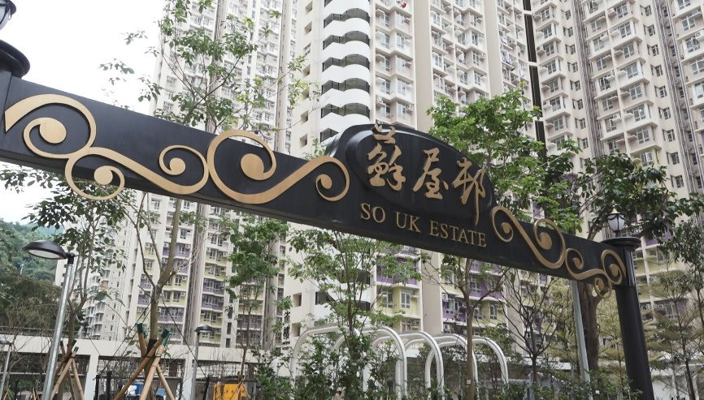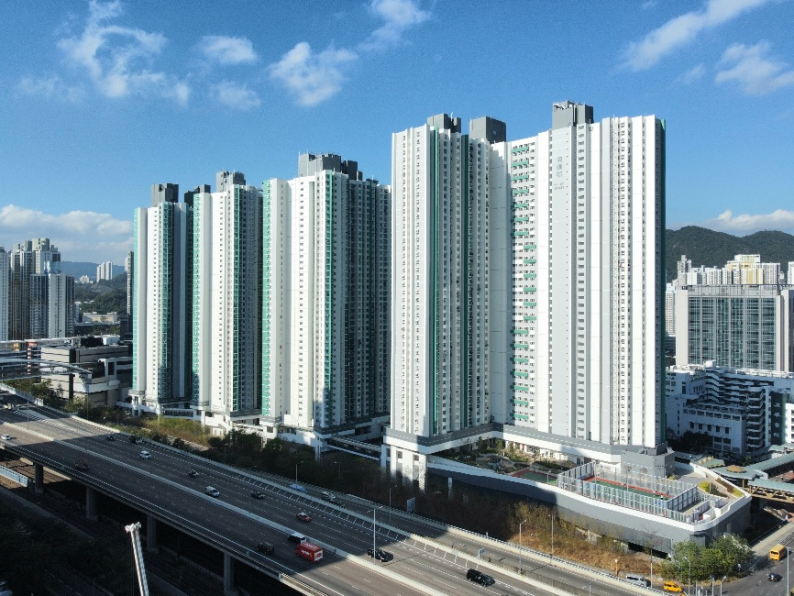
Project Description
COPSL provides daily operations, security, cleaning, and maintenance for So Uk Estate and Hoi Tat Estate are two prominent public housing estates in Sham Shui Po.
So Uk Estate is located at 380 Po On Road, Cheung Sha Wan. It comprises 14 residential blocks with approximately 6,985 rental flats accommodating about 18,600 residents. Completed in two phases in 2016 and 2019.
Hoi Tat Estate is located at 38 Sham Mong Road, Cheung Sha Wan. Completed between 2020 and 2022, it comprises four 40-storey residential blocks, providing approximately 3,335 rental flats accommodating about 9,500 residents.
Annual Conntract Sum: | HK$74.3M
Contract Period: | 2021/1/1-2028/12/31
Number of Rooms: | 10,320
Client: | Housing Authority
Details of awards and other performance-based prizes, accolades and letters of appreciation

2024/8 | 優異管理物業獎
2024/11 | 香港房屋經理學會-卓越獎
2024/11 | 香港房屋經理學會-最佳創新概念
2024/3 | 香港房屋委員會-最佳員工(物業管理)金獎

1.2.2 Universities Projects ,….

Project: | Postgraduate and faculty dormitories at the University of Macau (including the W32 Doctoral Building)
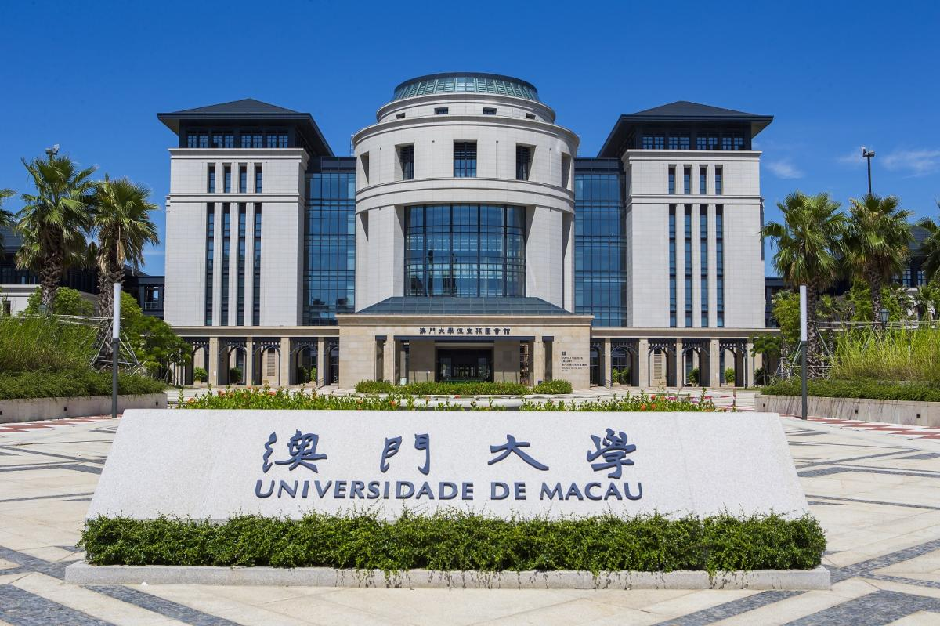

Project Description
Since first securing the contract in 2019, COPSL has successfully renewed its agreement, commencing its third consecutive term. The latest official tender for comprehensive campus facility maintenance and management services covers the period from January 1, 2026, to June 30, 2027. During its six years of service, the project team has handled move-in and move-out procedures for nearly 20,000 students and cleaned over 7,000 dormitory rooms, consistently receiving high praise from both the university and residents.
The main campus PGH is managed by the Student Resources Section, Student Affairs Office, and currently includes six residential blocks: S1, S2, S3, S4, W31, and W32. All rooms are fully furnished, equipped with air conditioning, and provide shared study rooms, fitness rooms, pantry areas, and laundry/drying rooms.
The W32 Doctoral Building is a notable residential tower, frequently referred to as the "Doctoral Building." It features two-person rooms sharing a bathroom, with most residents being PhD students. The building is equipped with four high-speed elevators per floor, two pantry areas, two drying rooms, and storage rooms. The ground floor (G/F) includes a central cooking area, study rooms, a piano room, a billiards room, and the property management office.
The Staff Quarters are located at the southern tip of the campus, comprising 16 residential buildings (11 of which are open for applications).
Annual Conntract Sum: | HK$11.8M
Contract Period: | 2019/7/1-2027/6/30
Client: | the University of Macau

Project: | The Education University of Hong Kong
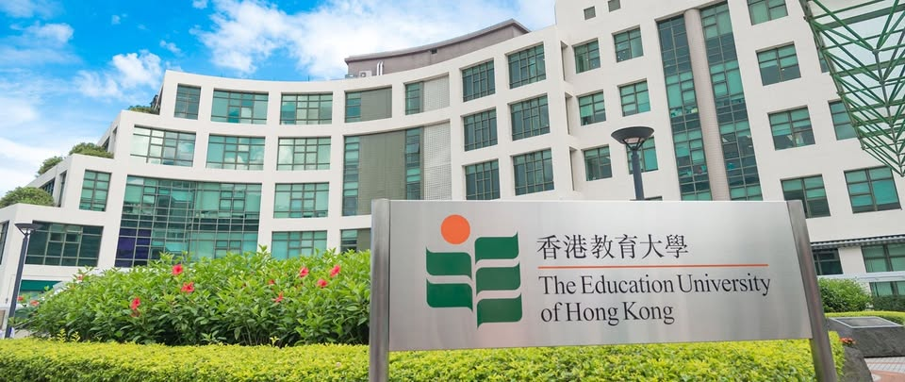

Project Description
COPSL deployed over 110 staff to cover the entire university, including the main Tai Po campus (approx. 12.5 hectares, including Student Hostels) and satellite centres in EdUHK Sports Centre, Tseung Kwan O Study Centre and North Point Study Centre.
A multi-layered security regime is in place. This includes a 24-hour Security Control Centre, which oversees daily supervision of security teams, contract performance monitoring, key control and enforcement of campus regulations. It also manages security systems such as CCTV, car-parking and transportation automation. Access control is strictly enforced, requiring staff and students to present their University ID, with visitors and contractors required to register at designated counters.
Annual Conntract Sum: | HK$33.4M
Contract Period: | 2025/10/1-2028/9/30
Client: | The Education University of Hong Kong

